CS342 Lab 3 Report

Professor Gertner

FAHEEM KAMAL

2019

**Table of Contents:**

**Objective 2**

**Functionality 2 - 5**

**Simulation 5 - 18**

**Analysis 18**

**Conclusion 19**

**Objective:**

In this lab, we had to create bitwise operations such as AND, OR, XOR, NOT, Shift and Right Rotations using VHDL files and testbench on Quartus and ModelSim. We will then test the designs on a DE2-115 board to see our results.

**Functionality:**

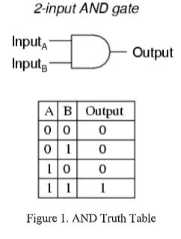**AND operation**

The output of AND operation results in 1 for inputs that are 1. Bitwise AND performs an operation for each bit separately. Ex. Input 010110 and 010111 will go through the AND gate and result in 0101.10

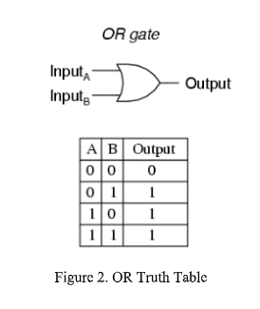**OR operation**

The output of OR will result in 0 for inputs that are both 0. Bitwise OR performs an operation for each bit separately. Ex: Input 010110 and 010111 will go through the OR gate and will result in 010111.

**XOR operation**

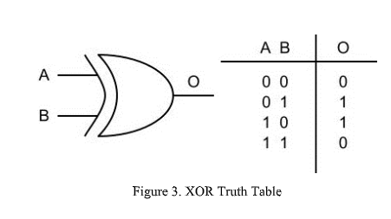

The XOR operations will result in 0 if the inputs are either 0 or 1. Other than that, it will be 1. Bitwise XOR performs operations for each bit separately. Ex: Two Inputs 010110 and 010111 will go through the bitwise XOR gate, then it will result in 101001.

**NOT operation**

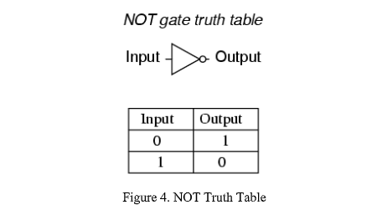

The NOT operations will result in a binary number where if the output is toggled from the input provided. When input is 1, the output will reflect as 0 and vice versa. Bitwise NOT performs operations for each bit separately. Ex: Input 010110 will go through the bitwise NOT gate, then it will result in 101001.

**Left Shift operation**

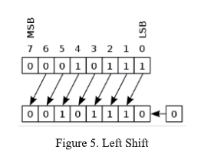

The Left Shift operation will result in a binary number that is shifted by 1 bit to the left from the input provided by the user. The least significant bit is filled up with a 0. Ex: For the input 010110 is applied, the output is then 001011.

**Right Shift operation**

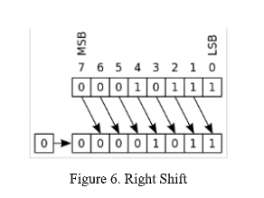

The Right Shift operation will result in a binary number that is shifted by 1 bit to the right from the input provided by the user. The most significant bit is filled up with a 0. Ex: For the input 010110 is applied, the output is then 101100.

**Left Rotation operation**

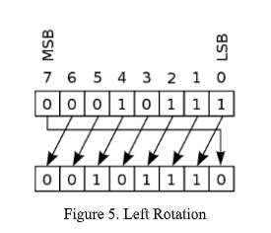

For the output of the Left Rotation operation, it results in a binary number where the output is shifted by 1 bit to the left from its input. The least significant bit is filled up with the input’s most significant value. Ex: Input is 010101, then the output is 101010.

**Right Rotation operation**

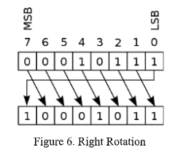

For the output of the Right Rotation operation, it results in a binary number where the output is shifted by 1 bit to the right from its input. The most significant bit is filled up with the input’s most significant value. Ex: Input is 010101, then the output is 101010.

**Simulation:**

The operations were created using a VHDL code. We have 4 input signals (Kamal_input1, Kamal_input2, Kamal_opcode) and a start button, which is also an input signal (Kamal_start). There is also a vector output, Kamal_result from the operations. They were then tested using ModelSim and VHDL testbench code.

Kamal_input1 and Kamal_input2 serve as signal operands that take 6-bit inputs and Kamal_start is the button that enables the operations. Kamal_opcode identifies the operation that needs to be executed (ex: AND, OR, etc). We use the switches on the DE2-115 board to choose the operations as well as the specific inputs. We have 8 operations in total, therefore we use 3 switches. Kamal_result shows the results from the inputs and operations. The following are used in the simulation:

**VHDL Code**

library ieee;

use ieee.std_logic_1164.all;

use ieee.numeric_std.all;

entity Kamal_Faheem_Lab3_Circuit is

Port(

Kamal_input1: in std_logic_vector(5 downto 0);

Kamal_input2: in std_logic_vector(5 downto 0);

Kamal_start: in std_logic;

Kamal_opcode: in std_logic_vector(2 downto 0);

Kamal_result: out std_logic_vector(5 downto 0)

);

end Kamal_Faheem_Lab3_Circuit;

architecture Kamal_arch of Kamal_Faheem_Lab3_Circuit is

begin

process(Kamal_start)

begin

if(Kamal_start = '1') then

case Kamal_opcode is

when "000" =>

Kamal_result <= Kamal_input1 and Kamal_input2; -- AND Gate

when "001" =>

Kamal_result <= Kamal_input1 or Kamal_input2; -- OR Gate

when "010" =>

Kamal_result <= not Kamal_input1; -- NOT Input1

when "011" =>

Kamal_result <= Kamal_input1 xor Kamal_input2; -- XOR Gate

when "100" =>

Kamal_result <= to_stdlogicvector(to_bitvector(Kamal_input1) sll 1); -- Shift Left Logical by 1

when "101" =>

Kamal_result <= to_stdlogicvector(to_bitvector(Kamal_input1) srl 1); -- Shift Right Logical by 1

when "110" =>

Kamal_result <= to_stdlogicvector(to_bitvector(Kamal_input1) rol 1); -- Rotate Left by 1

when "111" =>

Kamal_result <= to_stdlogicvector(to_bitvector(Kamal_input1) ror 1); -- Rotate Right by 1

when others =>

NULL;

end case;

end if;

end process;

end Kamal_arch;

**VHDL Testbench**

library ieee;

use ieee.std_logic_1164.all;

use ieee.numeric_std.all;

entity Kamal_Faheem_Lab3_CircuitTestBench is

end Kamal_Faheem_Lab3_CircuitTestBench;

architecture arch of Kamal_Faheem_Lab3_CircuitTestBench is

component Kamal_Faheem_Lab3_Circuit

port(

Kamal_input1: in std_logic_vector(5 downto 0);

Kamal_input2: in std_logic_vector(5 downto 0);

Kamal_start: in std_logic;

Kamal_opcode: in std_logic_vector(2 downto 0);

Kamal_result: out std_logic_vector(5 downto 0)

);

end component;

--Inputs

signal Kamal_input1: std_logic_vector(5 downto 0) := (others => '0');

signal Kamal_input2: std_logic_vector(5 downto 0) := (others => '0');

signal Kamal_opcode: std_logic_vector(2 downto 0) := (others => '0');

signal Kamal_start: std_logic;

--Outputs

signal Kamal_result: std_logic_vector(5 downto 0);

begin

uut: Kamal_Faheem_Lab3_Circuit port map(

Kamal_input1 => Kamal_input1,

Kamal_input2 => Kamal_input2,

Kamal_opcode => Kamal_opcode,

Kamal_start => Kamal_start,

Kamal_result => Kamal_result

);

stim_proc: process

begin

wait for 100 ns;

Kamal_input1 <= "010110";

Kamal_input2 <= "010111";

Kamal_start <= '1';

Kamal_opcode <= "000";

wait for 100 ns;

Kamal_opcode <= "001";

wait for 100 ns;

Kamal_opcode <= "010";

wait for 100 ns;

Kamal_opcode <= "011";

wait for 100 ns;

Kamal_opcode <= "100";

wait for 100 ns;

Kamal_opcode <= "101";

wait for 100 ns;

Kamal_opcode <= "110";

wait for 100 ns;

Kamal_opcode <= "111";

end process;

end;

**Pin Assignments:**

To, Location

Kamal_input1[0], PIN_AB28

Kamal_input1[1], PIN_AC28

Kamal_input1[2], PIN_AC27

Kamal_input1[3], PIN_AD27

Kamal_input1[4], PIN_AB27

Kamal_input1[5], PIN_AC26

Kamal_input2[0], PIN_AD26

Kamal_input2[1], PIN_AB26

Kamal_input2[2], PIN_AC25

Kamal_input2[3], PIN_AB25

Kamal_input2[4], PIN_AC24

Kamal_input2[5], PIN_AB24

Kamal_start, PIN_M23

Kamal_opcode[2], PIN_Y23

Kamal_opcode[1], PIN_Y24

Kamal_opcode[0], PIN_AA22

Kamal_result[0], PIN_E21

Kamal_result[1], PIN_E22

Kamal_result[2], PIN_E25

Kamal_result[3], PIN_E24

Kamal_result[4], PIN_H21

Kamal_result[5], PIN_G20

**Inputs:** Kamal_input1, Kamal_input2, Kamal_opcode and Kamal_start

**Outputs:** Kamal_result

The figure above shows the opcode used in the lab and each code was set to a specific operation.

|  |  |
| --- | --- |
| **Opcode** | **Operation** |
| 000 | Result = A and B |
| 001 | Result = A or B |
| 010 | Result = not A |
| 011 | Result = A xor B |
| 100 | Result = A << shamt (Left Shift) |
| 101 | Result = A >> shamt (Right Shift) |
| 110 | Result = A rol (Rotation Left) |
| 111 | Result = A ror (Rotation Right) |

**Opcode 000 (AND)**

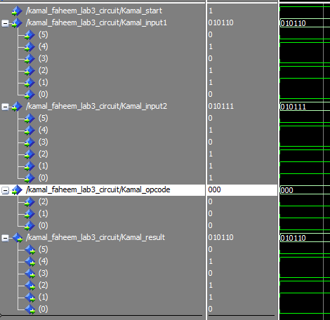

**Opcode 001 (OR)**

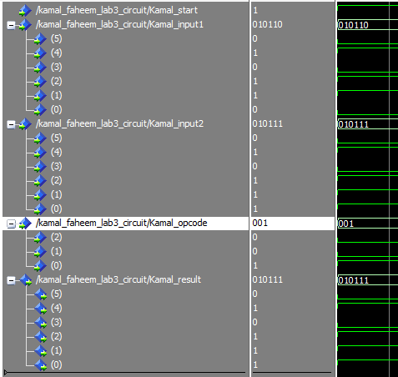

**Opcode 010 (NOT)**

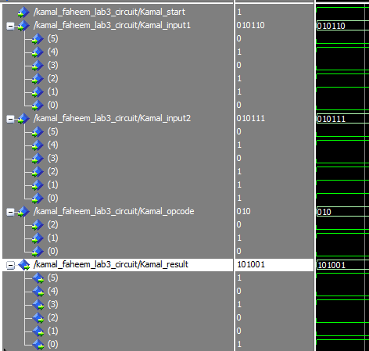

**Opcode 011 (XOR)**

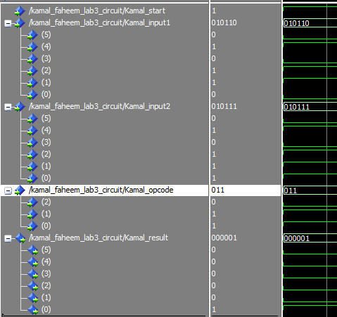

**Opcode 100 (Left Shift)**

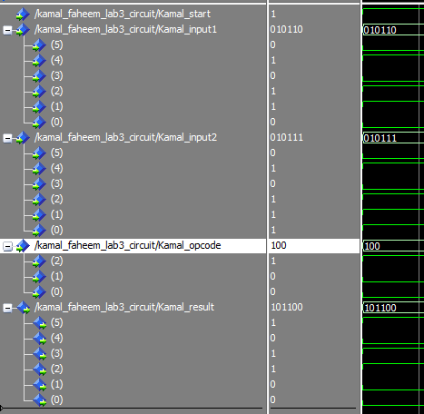

**Opcode 101 (Right Shift)**

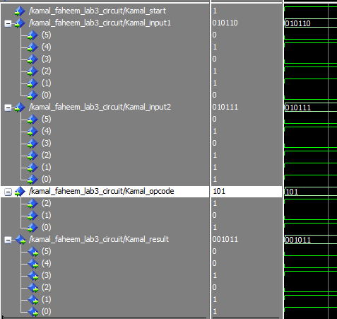

**Opcode 110 (Left Rotation)**

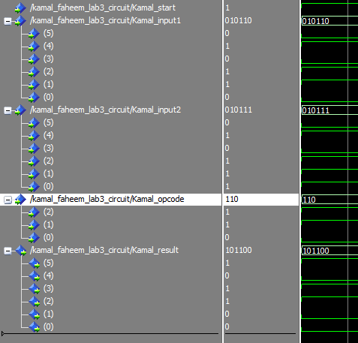

**Opcode 111 (Right Rotation)**

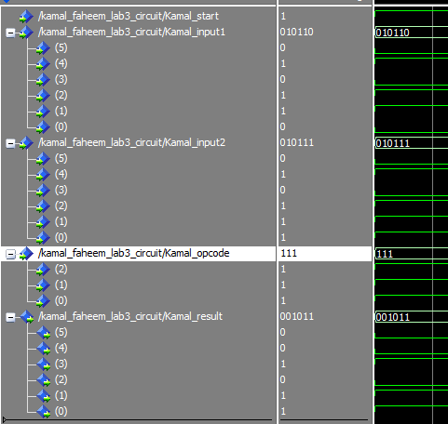

The figures below show the pin assignments used for the DE2-115 Board. Kamal_input1 and Kamal_input2 were assigned to switches 0 to 11, Kamal_opcode was assigned to switches 15 to 17. Kamal_start was assigned to key 0 and the output Kamal_result was assigned to green LEDs 0 to 5 on the board.

**DE2-115 AND Opcode**

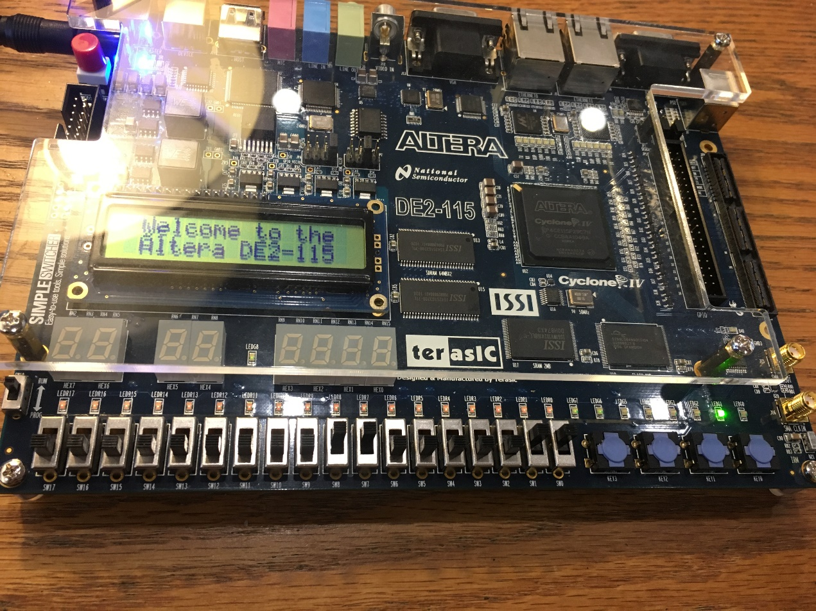

**DE2-115 OR Opcode**

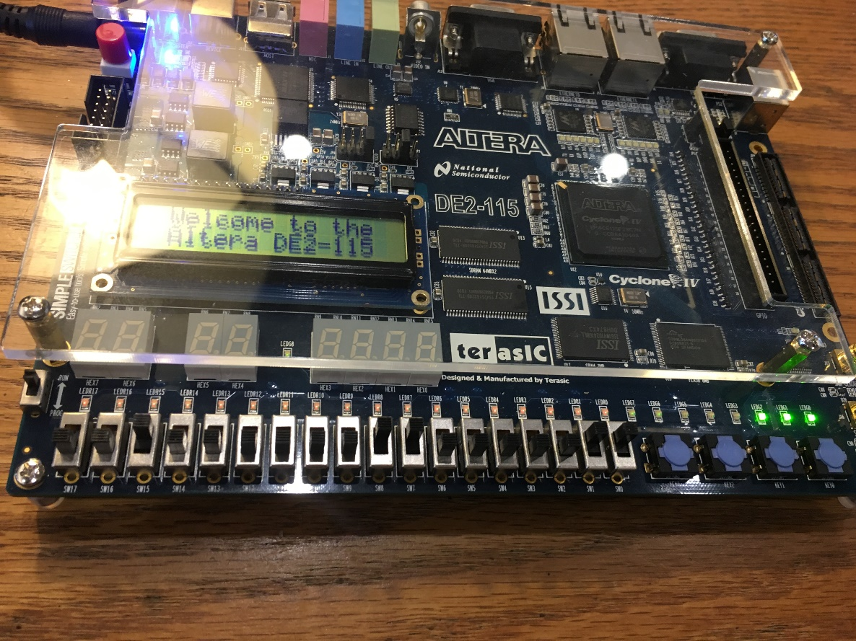

**DE2-115 XOR Opcode**

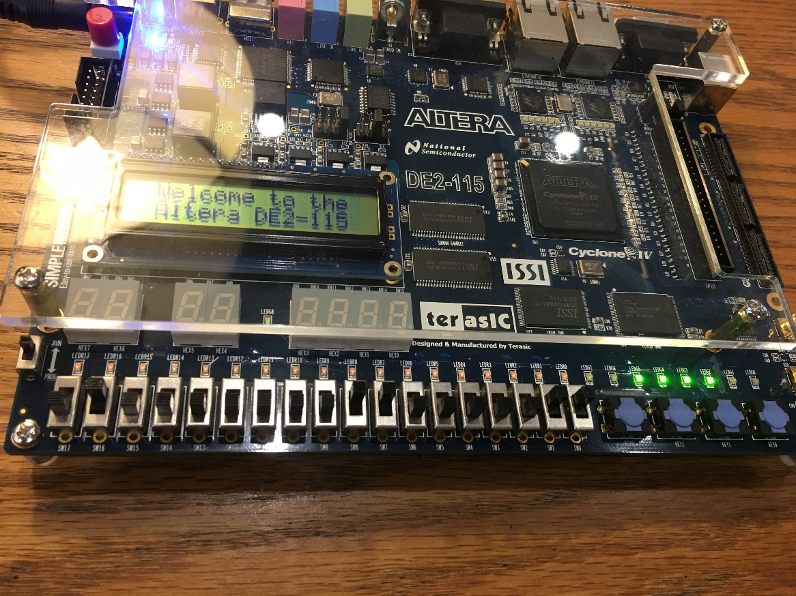

**DE2-115 NOT Opcode**

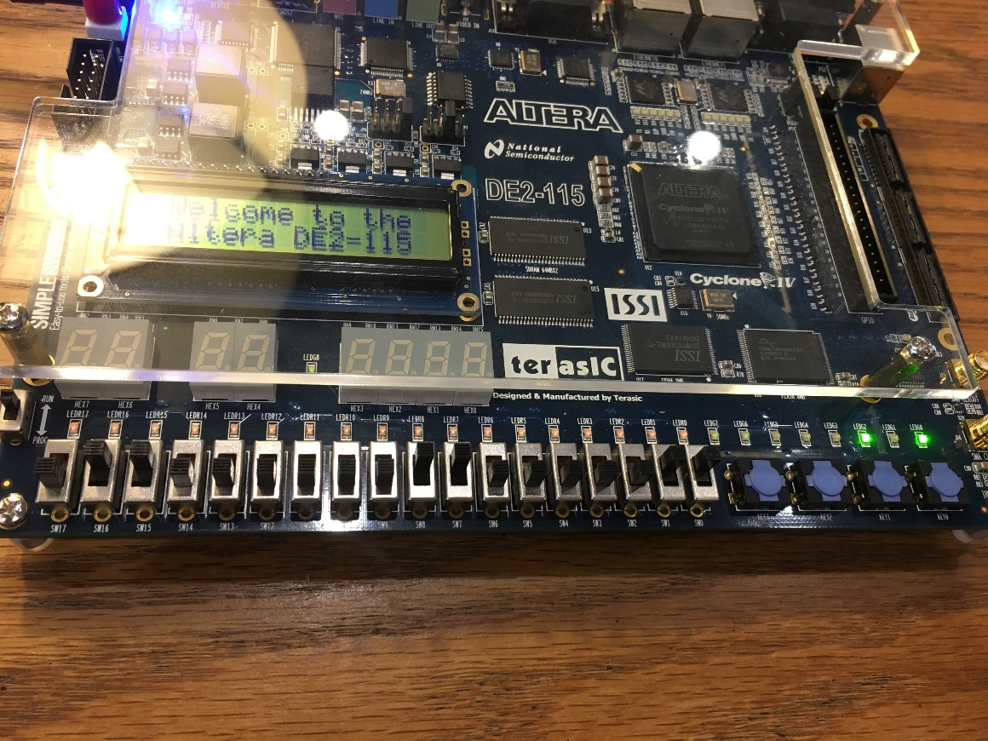

**DE2-115 Left Shift Opcode**

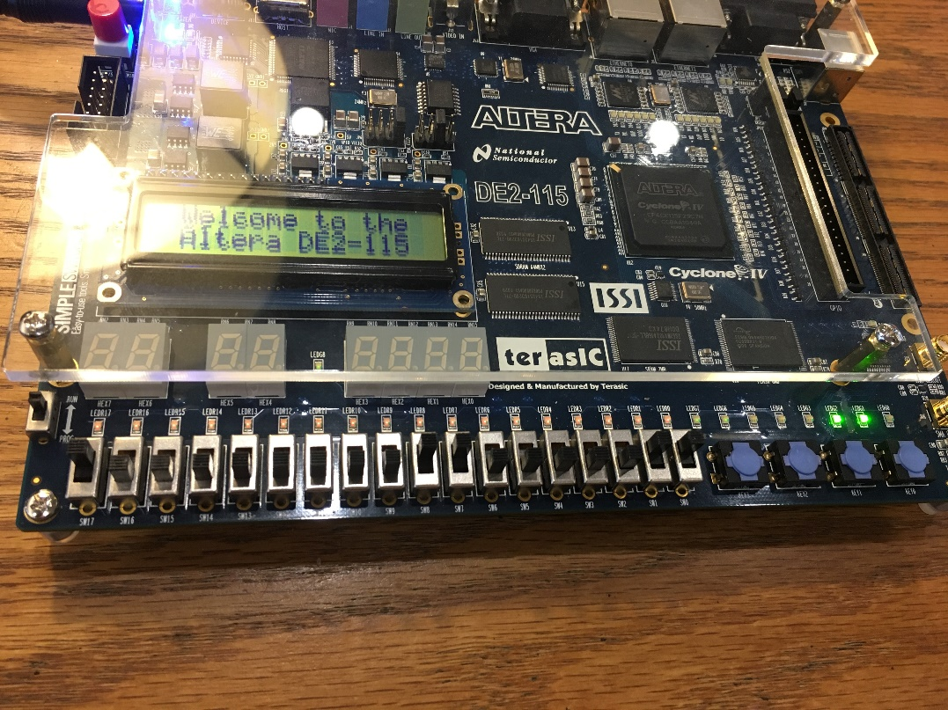

**DE2-115 Right Shift Opcode**

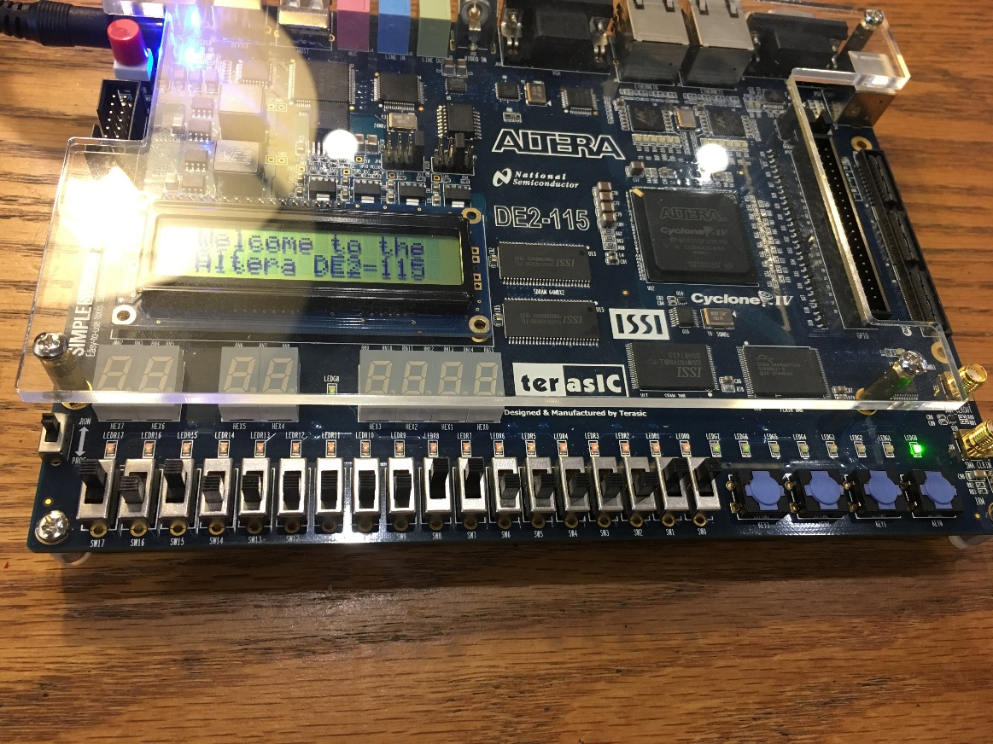

**DE2-115 Left Rotation Opcode**

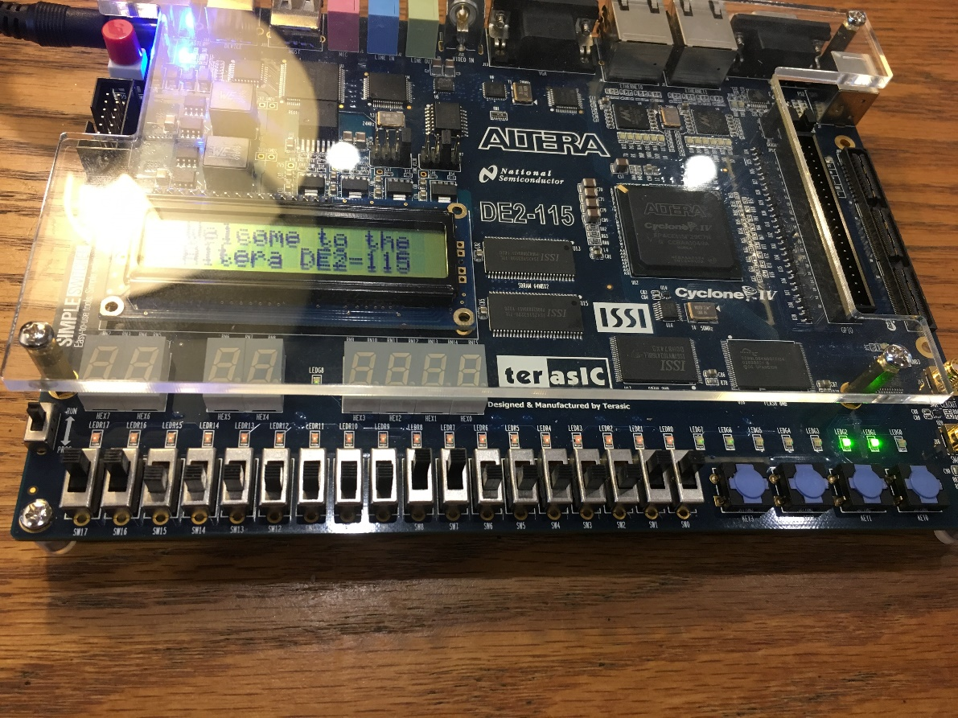

**DE2-115 Right Rotation Opcode**

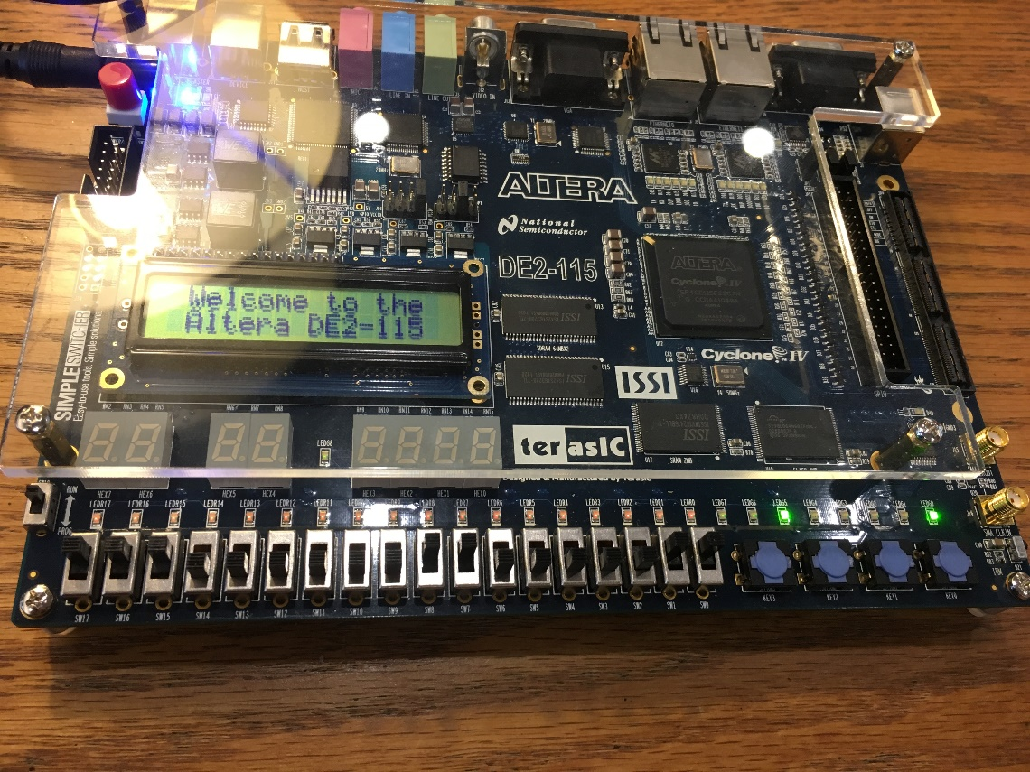

**Analysis:**

For the operations implemented in this lab using VHDL, these can be implemented in high-level languages such as C++, C or Java. We have such operators (&, |, *<<*, >>, ~, ^) can be used as bitwise operators. Using loops for the left and right rotations are useful in a way where you use temporary variables to store values and move their locations in either direction.

In order to multiply by 2, we can use the Left Shift operation since the operations results with two of the same inputs being added together. This only applies with binary numbers since with binary numbers, moving to the left or right requires only multiplication or division by 2. For other systems, such as octal, we need to use 8 to move to the right or left bit. Another such example, with decimal, we need to use 10 to move to the right or left.

For multiplication or division by multiplies of 2, we can use left and right shift operations. If we want to divide or multiply by 2, we can make it by shifting to the left or right by 1 bit. If we want to multiply by 2x2 or 2^2, we can shift to the left or right by 2 bits. So, we can perform this by shifting bits by n/2.

**Conclusion:**

This lab is essential in helping me understand how bitwise operations work. I learned that the start button acts as a trigger that allows the operation that I select to execute. Furthermore, I learned to use similar operations successfully on paper but with this lab, each operation gave me the results I had expected.